# CS 255 System Design Document Template

This template lays out all the different sections that you need to complete for Project Two. Each section has guidance to prompt your thinking. You will need to continually reference the interview transcript as you work to make sure that you are addressing your client’s needs. There is no required length for the final document. Instead the goal is to complete each section based on what your client’s needs are. Remove this note when you are finished, and replace all bracketed text with the relevant information.

## UML Diagrams

### UML Use Case Diagram

*[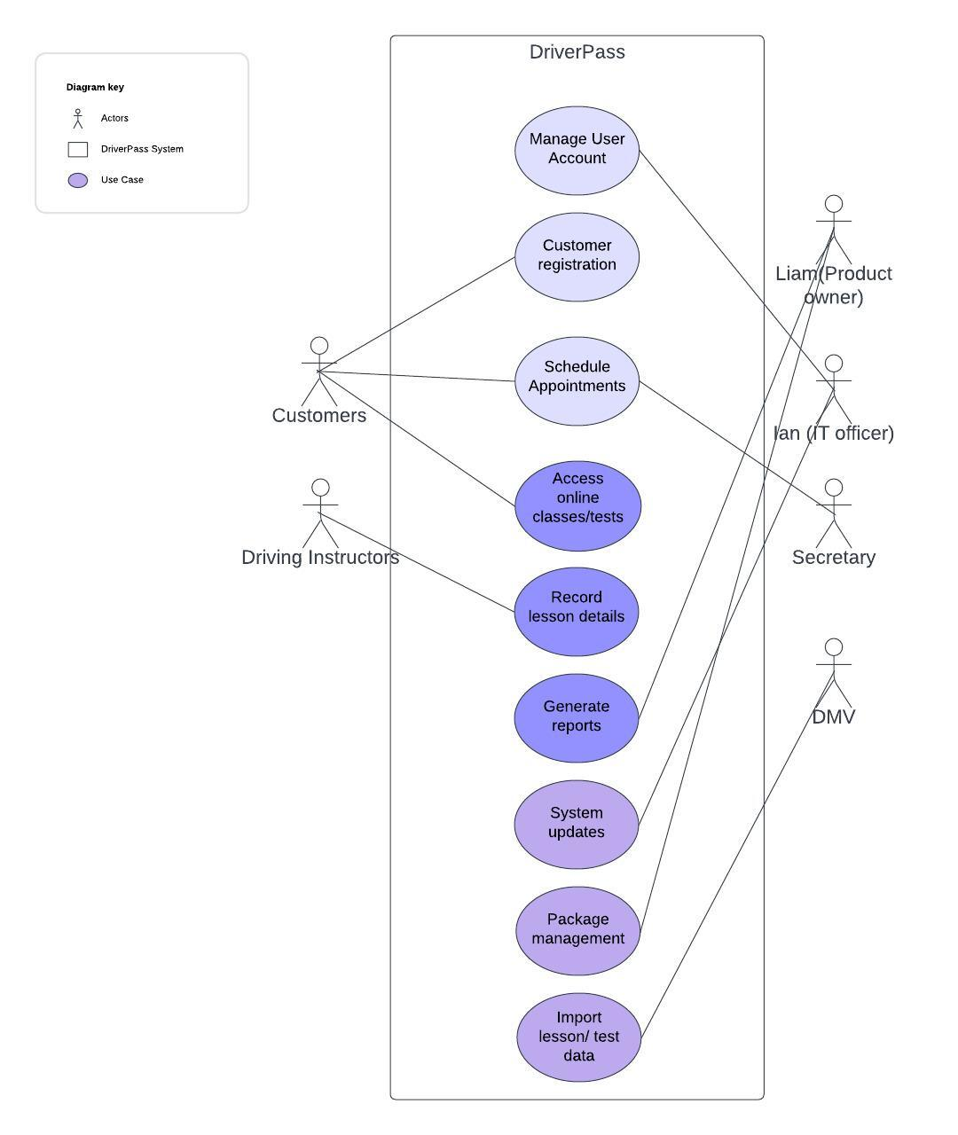]*

### UML Activity Diagrams

*[*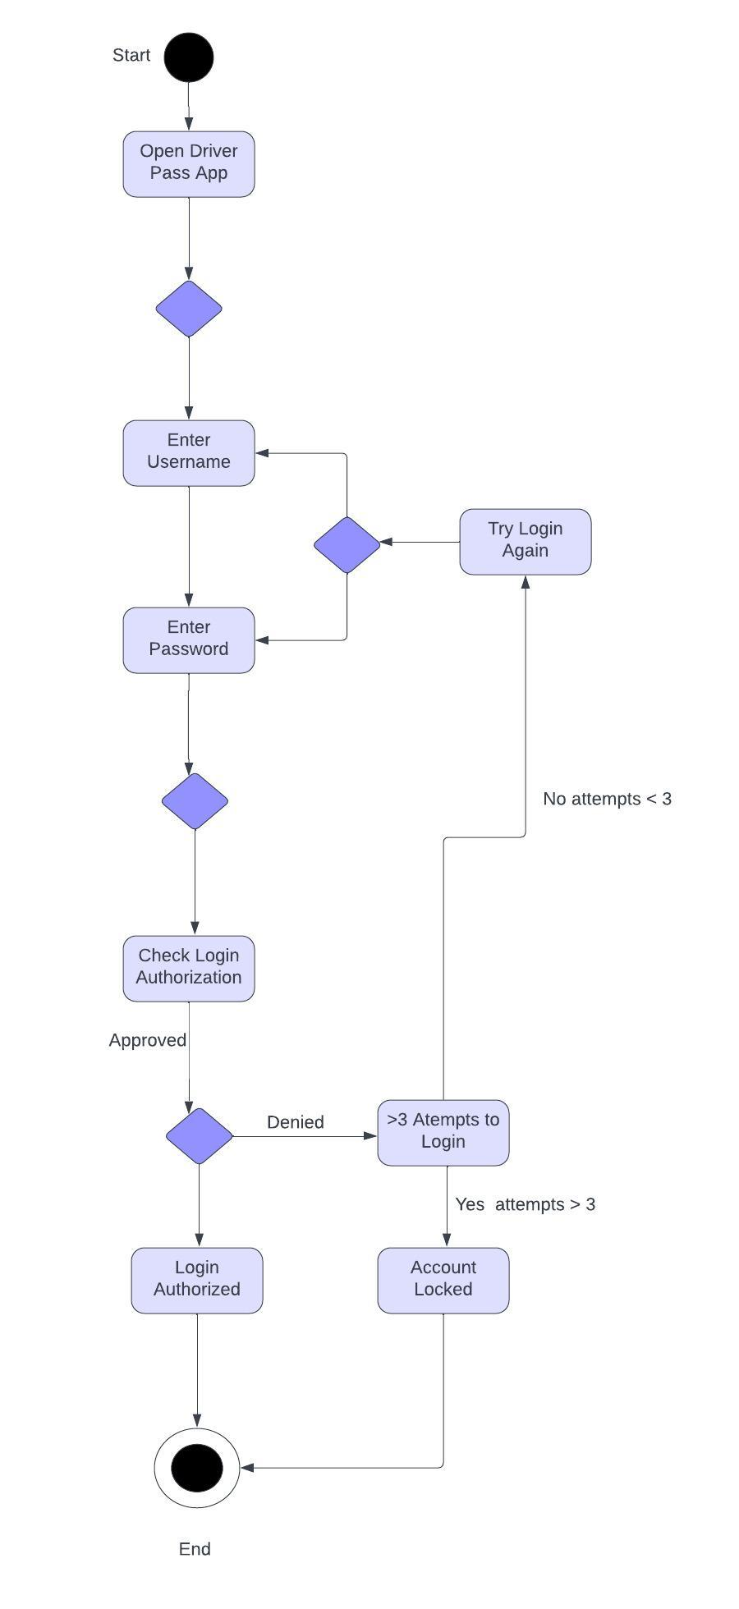  
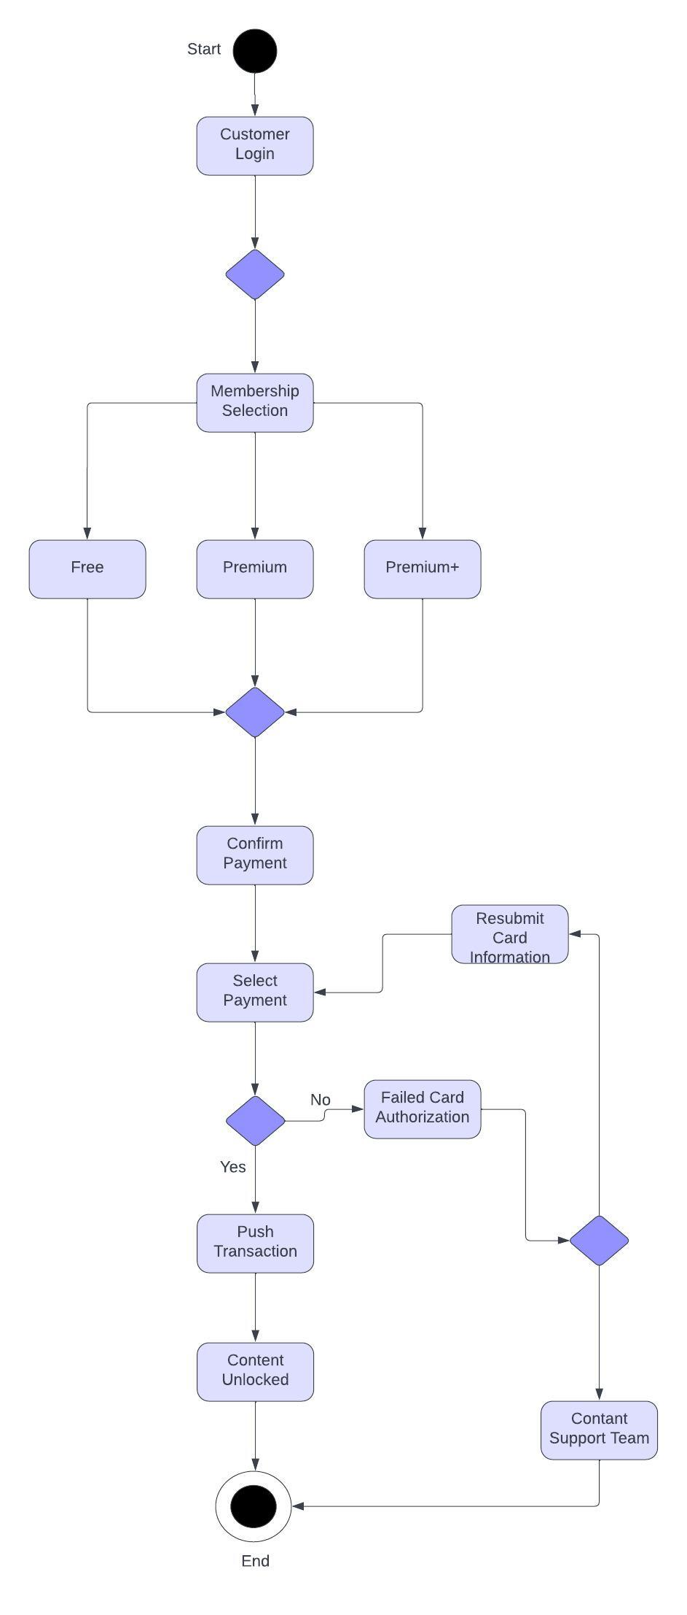  
*]*

### UML Sequence Diagram

*[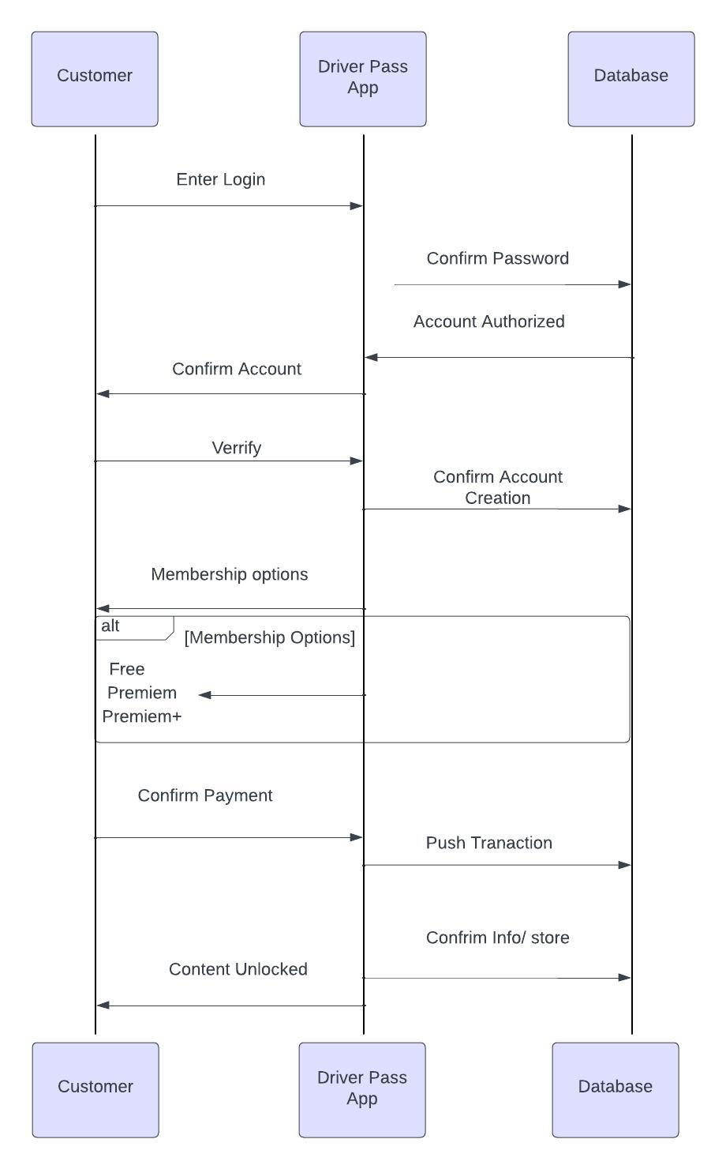]*

### UML Class Diagram

*[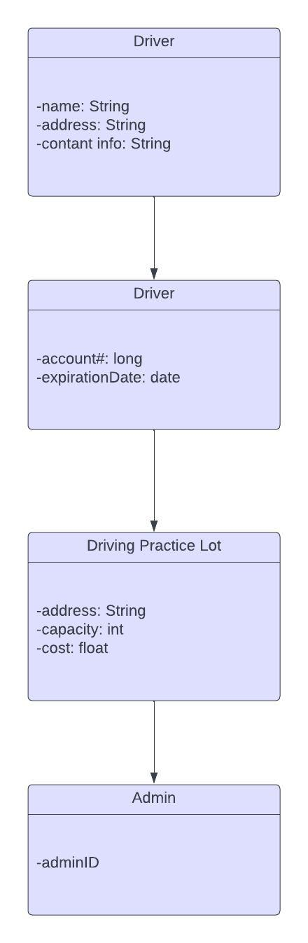]*

## Technical Requirements

*[*

**Hardware Requirements:**

- Server infrastructure for hosting the DriverPass application and database.

- Reliable internet connection for server connectivity.

- End-user devices (smartphones, tablets, computers) for accessing the DriverPass app.

**Software Requirements:**

- Operating systems (OS) for servers (e.g., Windows Server, Linux) and end-user devices (e.g., iOS, Android, Windows).

- Database management system (DBMS) for storing user data, payment information, and transaction records.

- Web server software (e.g., Apache, Nginx) for handling web requests.

**Development Tools:**

- Integrated Development Environment (IDE) for coding (e.g., Visual Studio, Eclipse).

- Version control system (e.g., Git) for source code management.

- Project management and collaboration tools (e.g., JIRA, Trello).

**Application Software:**

- Mobile app development platforms (e.g., React Native, Flutter) for DriverPass app.

- Backend development framework (e.g., Node.js, .NET Core).

- Front-end development tools and libraries (e.g., React, Angular).

**Infrastructure:**

- Cloud services (e.g., AWS, Azure) for hosting and scalability options.

- Security infrastructure, including firewalls and SSL certificates.

- Backup and recovery solutions for data redundancy.

**Security Requirements:**

- Encryption for data at rest and in transit (e.g., AES, TLS).

- Authentication and authorization mechanisms (e.g., OAuth, JWT).

- Regular security updates and patch management.

**Payment Processing:**

- Integration with payment gateways (e.g., Stripe, PayPal) for handling transactions.

- PCI DSS compliance for handling credit card information.

**User Interface:**

- Responsive design for the DriverPass app to accommodate various device sizes.

- Accessible design compliant with WCAG for users with disabilities.

**Testing and Deployment:**

- Continuous integration and continuous deployment (CI/CD) pipeline for streamlined development.

- Automated testing tools for unit, integration, and system tests.

- Staging environment for pre-production testing.

**Monitoring and Support:**

- Application performance monitoring (APM) tools (e.g., New Relic, Datadog).

- Log management and analysis tools (e.g., Splunk, ELK stack).

- Customer support infrastructure (e.g., helpdesk software, chatbots).

These requirements form the technical foundation necessary for developing, deploying, and maintaining the DriverPass system as depicted in the UML diagrams. The actual selection of specific technologies may vary based on the organization's preferences, budget, and existing infrastructure.*]*